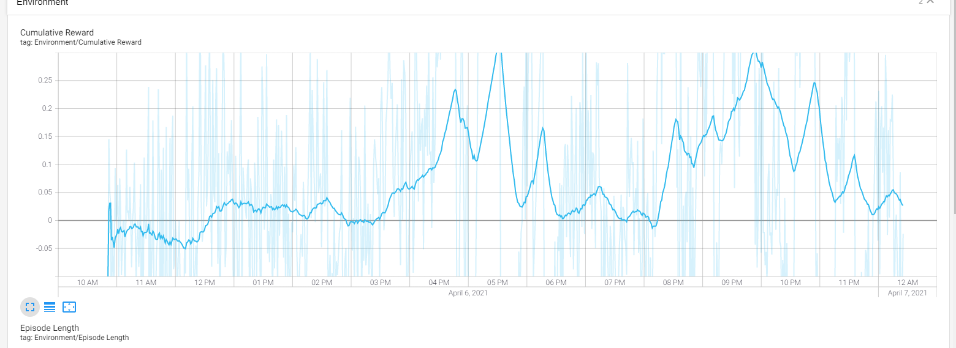

* When we first trained the agent, it took a while for the agent to figure out what the objective was. Eventually it figured it out and then it started having spikes of progress. Although it could be because it figured out an exploit where they would rush the ball and try to score a goal.

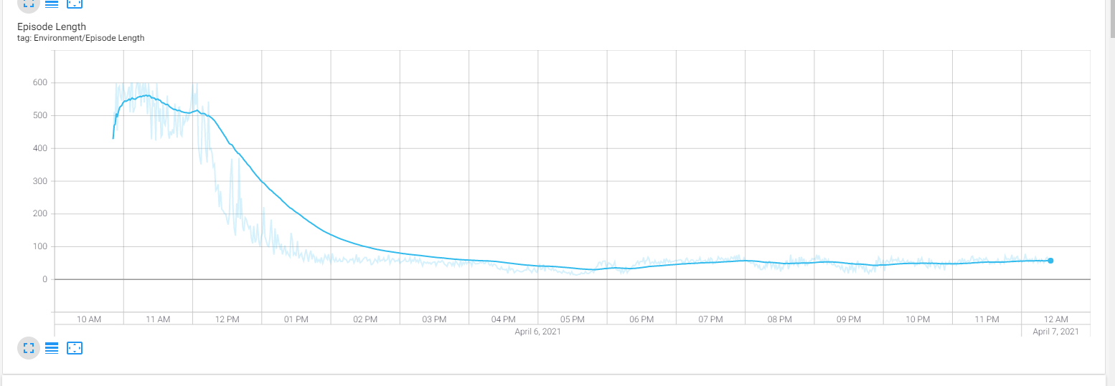

* We trained the agent for about a day and a half, I started at 10 am on April 6 and then left my PC on for a whole day. Eventually the scenarios began to quickly shorten in terms of length as the agent has figured out the game and some exploits.